**Configuration Manager Settings for Internet Information Services(IIS) and SQL Server Management Studio (SSMS)**

**Configuration IIS:**

1. We need to validate whether the SSL Certificate is working fine or not
2. Cross Platform API request CORS shall be there to inject the API request from the foreign domain.
3. Changes made in the app setting.json shall not be incorporated in the Commit changes in the Git

**Configuration in SSMS:**

1. Go to the following folder location if you have SQL Server Management Studio 2017 installed in your web server or the machine whether the development is taking place.
2. Check for the TCP/IP protocol changes required for the services in SSMS.
3. Change the following services
4. Navigate to the folder: C:\Windows\SysWOW64\SQLServerManager14.msc
5. Now Click Ok to run the app
6. Here we get the following screen

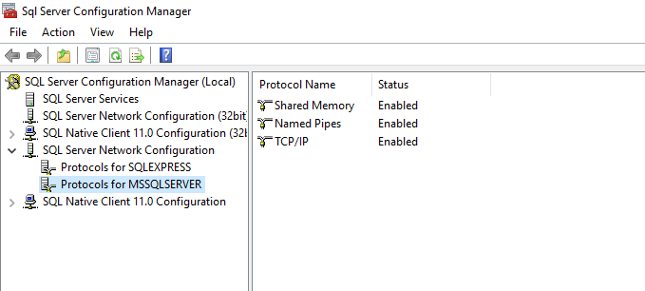

1. Now under Protocols for SQLExpress and Protocols for MSSQLServer check for the services running under these instances.
2. Enable all the three components under it.
3. Then close the SQL Server Configuration Manager and Run the services.msc in your machine.
4. This will open another window

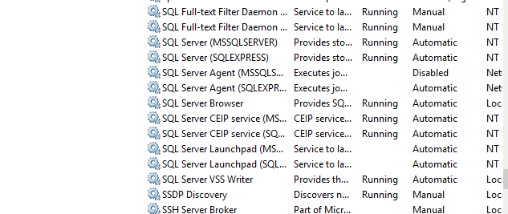

1. Now stop the SQL Server Agent Both the services and again manually start the same.
2. A restart is necessary for the last settings to get up and running.